S3 Bucket
What is amazon s3?
Amazon S3 (Simple Storage Service) cloud-based object storage service offered by AWS.
-It's designed to store and retrieve any amount of data from anywhere on the web, making it a foundational service for cloud computing.
-Amazon S3 provides management features so that you can optimize, organize, and configure access to your data to meet your specific business, organizational, and compliance requirements.

Features:
- It is a global service.
- High latency and high throughput performance.
- It is safe place to store your files.
- It is Object based storage. Files are stored as object.
- Durability: AWS claims Amazon S3 to have a 99.999999% of durability. Means possibility of loosing our data stored on S3 is one in billion.
- A single Amazon S3 object can store maximum of 5 terabytes (5TB). A total volume an s3 bucket can store is unlimited. Ways of uploading your file to s3:
- Console (GUI) upto 160GB file we can upload
- Winscp upto 160GB file we can upload
- CLI/ Powershell for uploading files from 5GB to 5TB AWS use multipart upload
- Storage Classes: Choose based on access frequency and cost:
  - S3 Standard
  - S3 Intelligent-Tiering
  - S3 Standard-IA (Infrequent Access)
  - S3 One Zone-IA
  - S3 Glacier & Glacier Deep Archive (for archival)
- Versioning: Preserve, retrieve, and restore every version of an object.
- Lifecycle Policies: Automate transitions between storage classes or deletions.
- Replication: Cross-region or same-region replication for disaster recovery.
- Event Notifications: Trigger workflows (e.g., Lambda functions) on object events.
- Access Control: IAM policies, bucket policies, ACLs, and S3 Access Points.
- Encryption: Server-side (SSE-S3, SSE-KMS, SSE-C) and client-side encryption.
- Data Consistency: Strong read-after-write consistency for all operations.

S3 – Restriction and Limitations:

Bucket-Level Restrictions
- Bucket Count: You can create up to 10,000 buckets per AWS account by default. To exceed this, you must request a quota increase.
- Bucket Ownership: Buckets are owned by the AWS account that creates them. Ownership is non-transferable.
- Bucket Naming: Bucket names must be globally unique and follow DNS-compliant naming rules (e.g., lowercase letters, numbers, hyphens). Once we select name and region for s3 bucket we cannot change it.
Object-Level Limitations
- Object Size:
  - Minimum: 0 bytes
  - Maximum: 5 TB per object
  - For uploads larger than 5 GB, you must use multipart upload.
- Number of Objects: No limit on the number of objects per bucket, but performance may degrade if not properly managed.
- Key Length: Object key names can be up to 1,024 bytes in UTF-8.

How to send request to increase quota?
Step 1: Click on username. Select service quota.
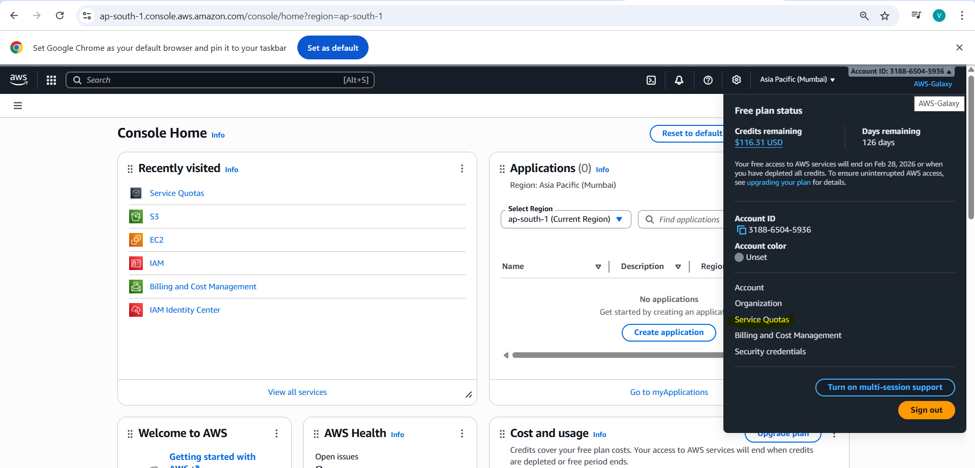
Step 2: Click on AWS services
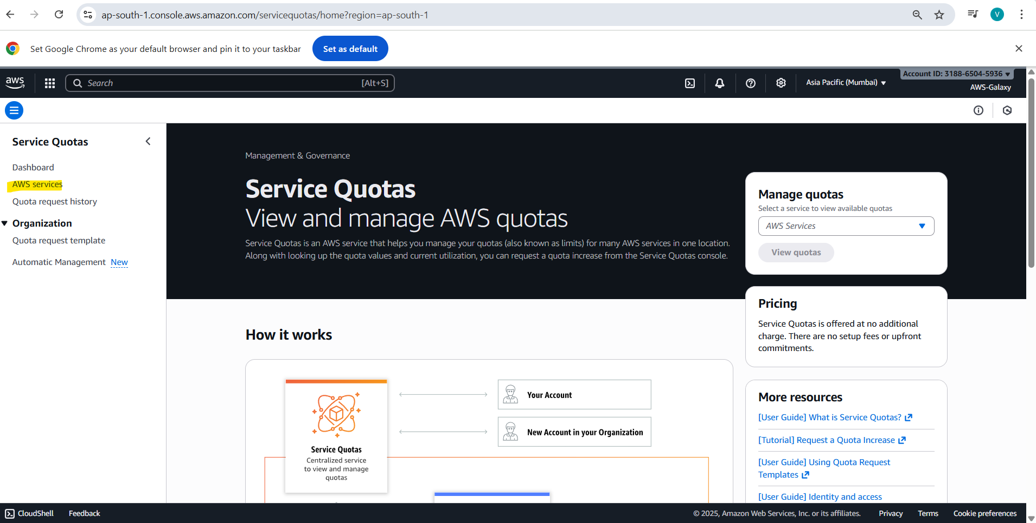
Step 3: Search for the particular service 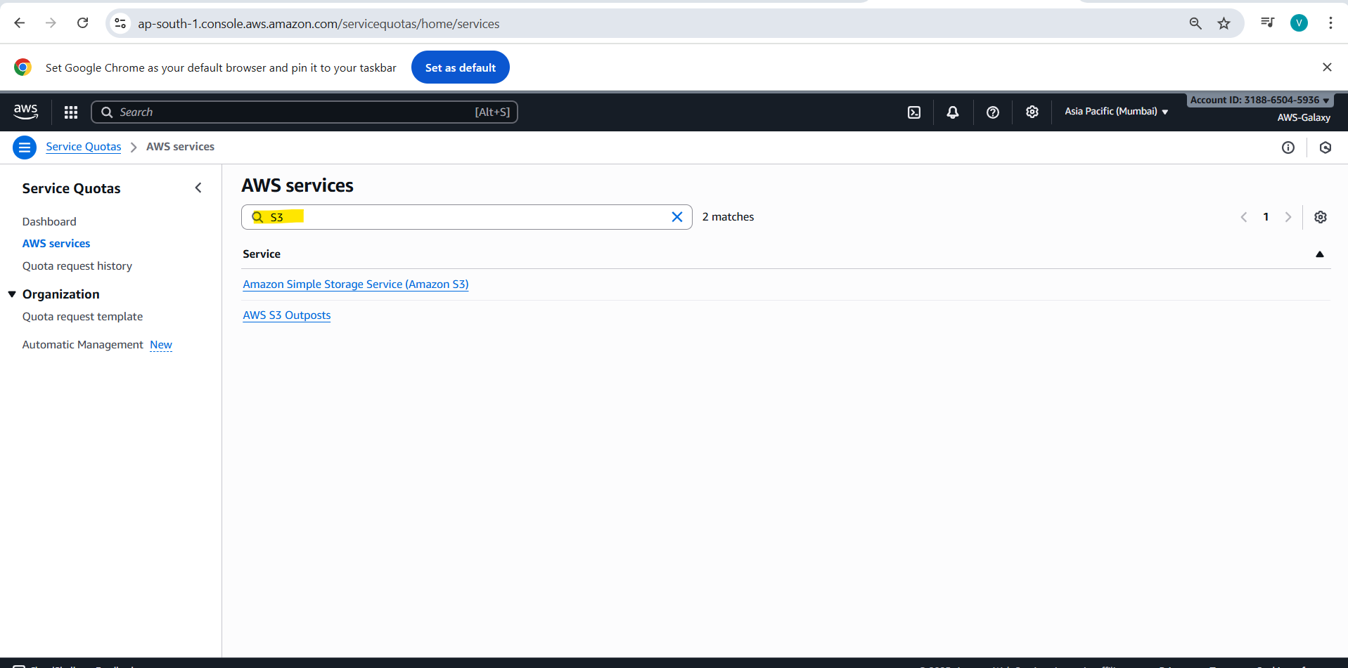Step 4: click on directory buckets 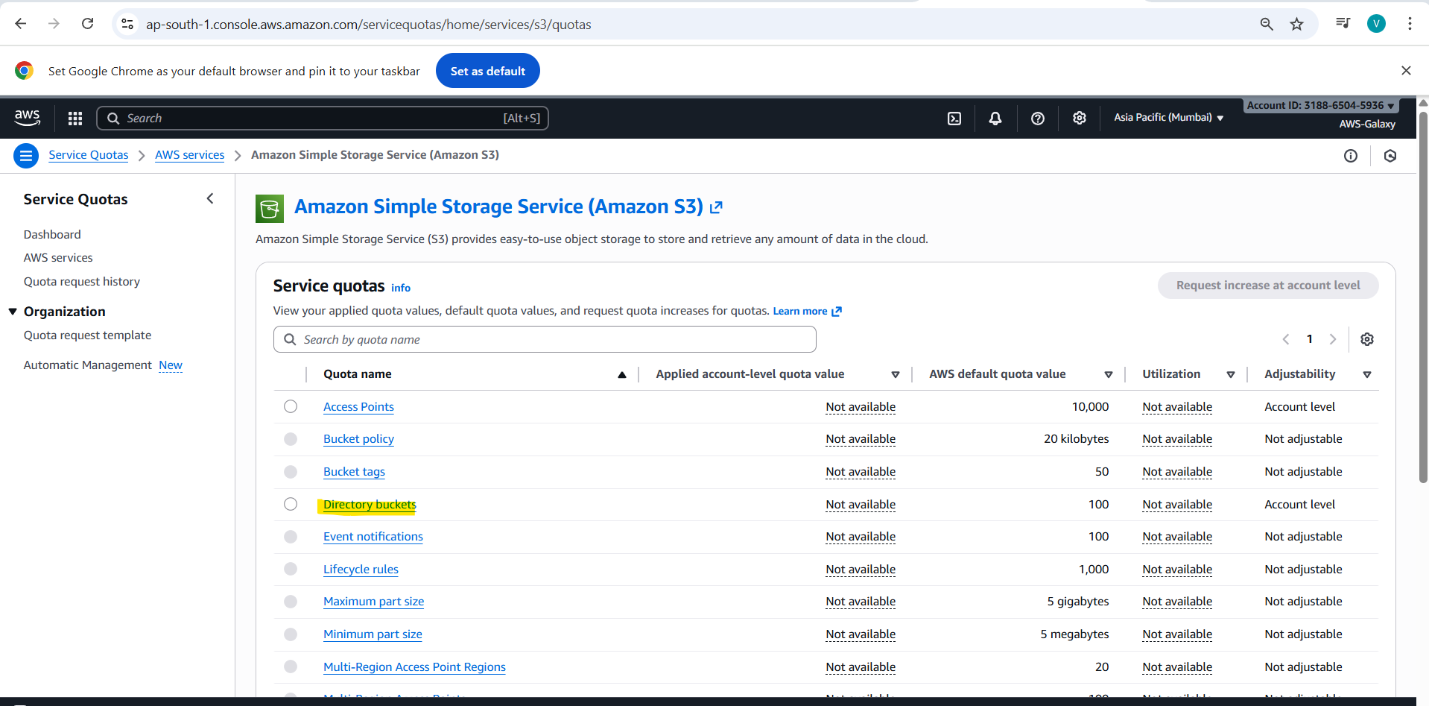Step 4: click on “Request increase at account level”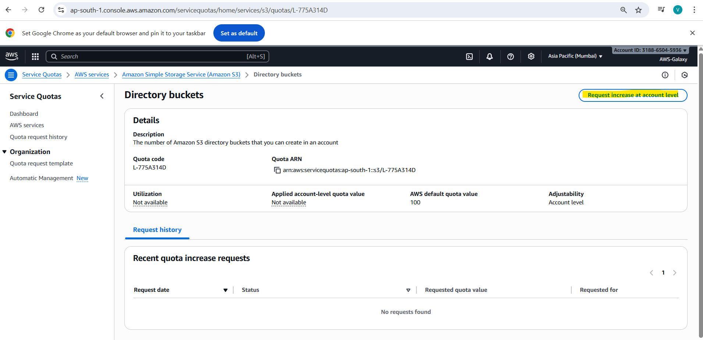
Step 5: Provide the value. 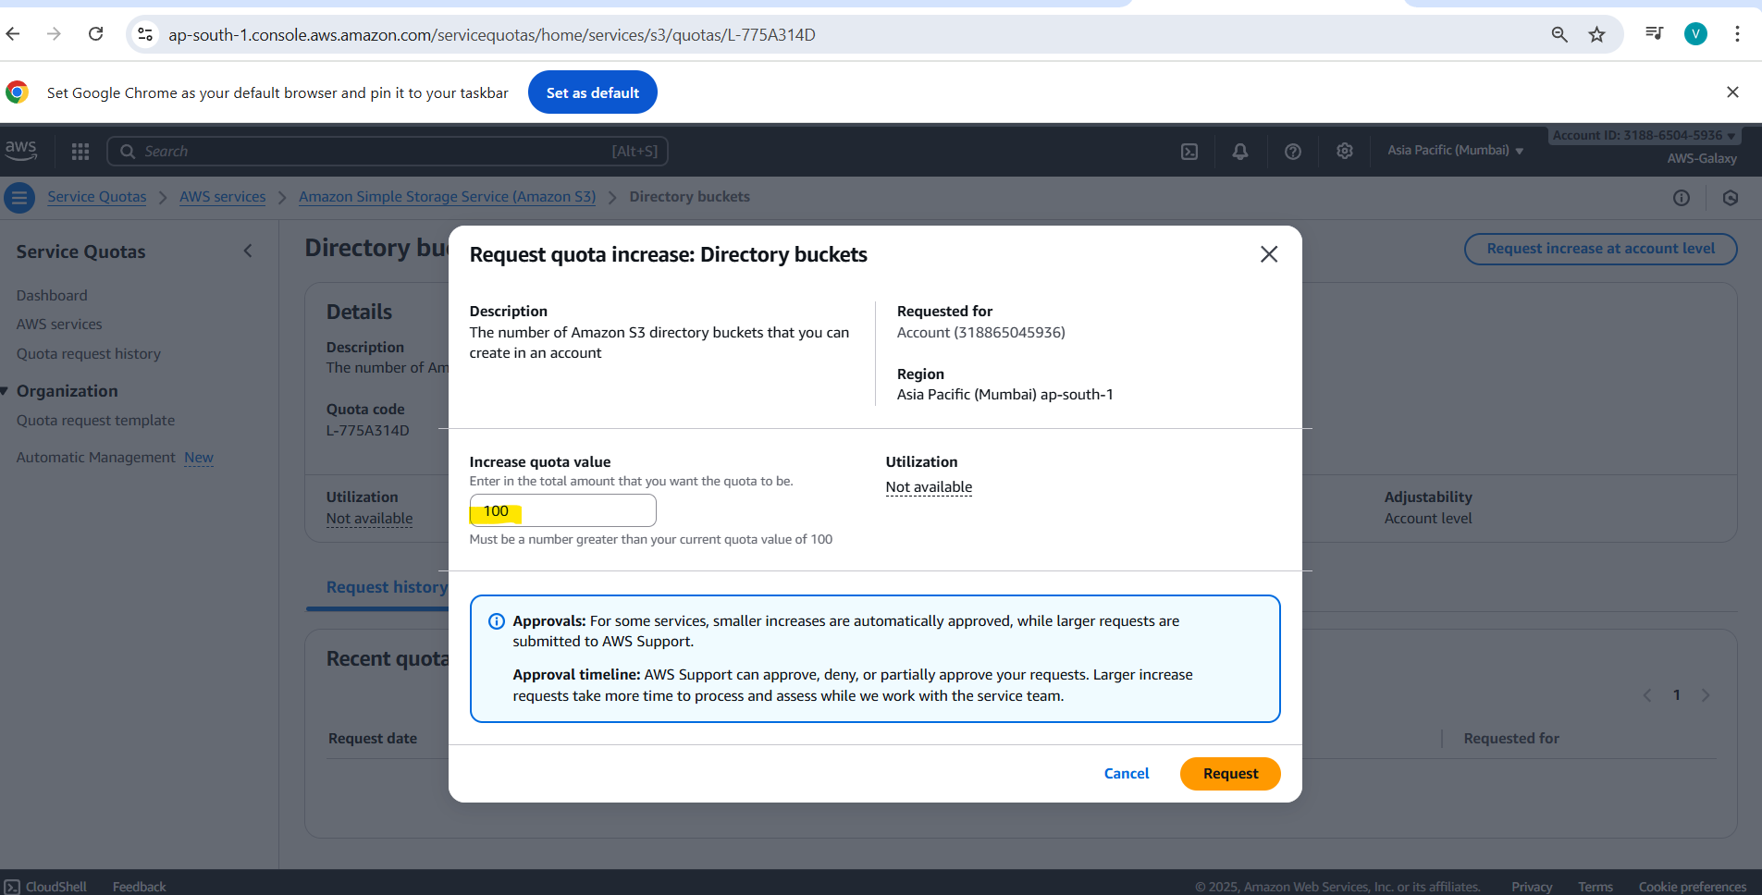
Step 6: Click on Request. It will go for for approval. Once approved you can create as many buckets as you requested.

Note: S3 service we cannot link directly to EC2 machines. But we can link it to our applications, websites using API.
How much data we can store in s3 bucket?
Unlimited.
Max size of 1 file is 5TB.

How to create s3 bucket?
Step 1: Login to aws console
Step 2: search for s3
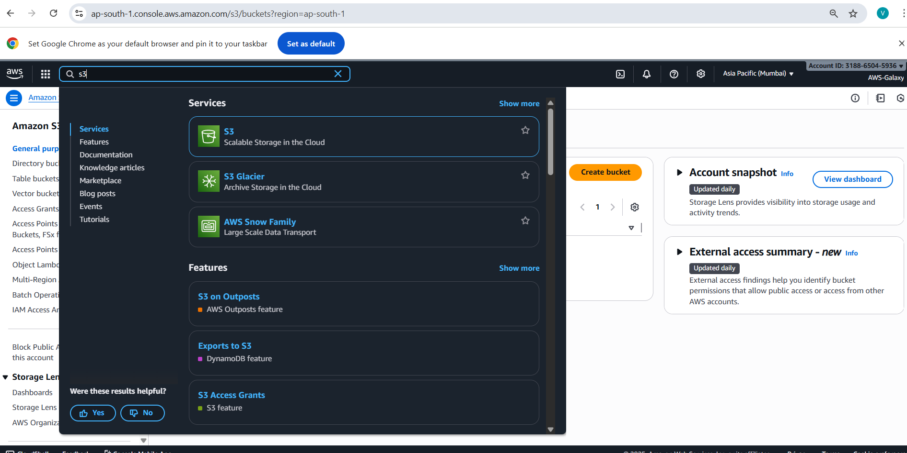
Step 4: Select s3 and click on “General purpose buckets”. Here it will display all the buckets from all regions. But while creating bucket you should have to select region 1st then you can go for creating bucket. Click on create bucket option.
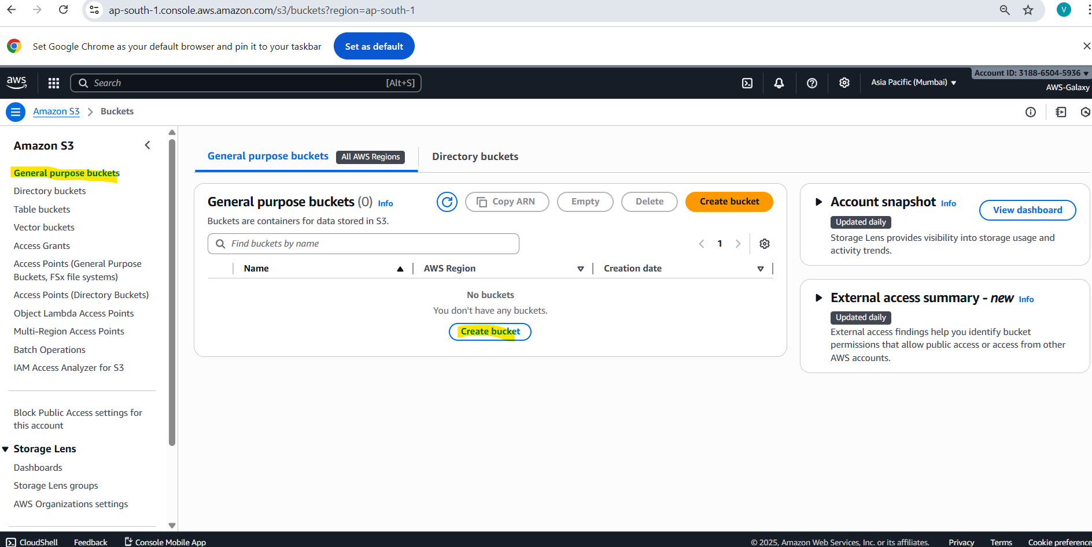
Step 5: Give unique name to your bucket. If you try to use existing name it will throw error. It will not allow it.
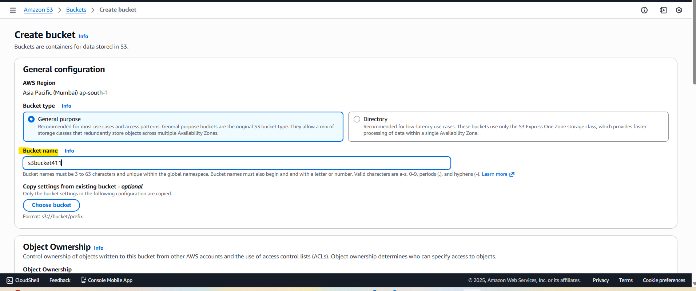
Step 6: Select Object ownership as ACLs enabled.
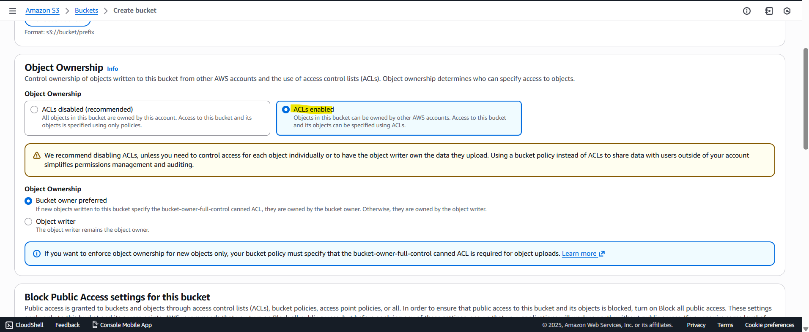
Step 7: Deselect check box to allow public access and acknowledge it.
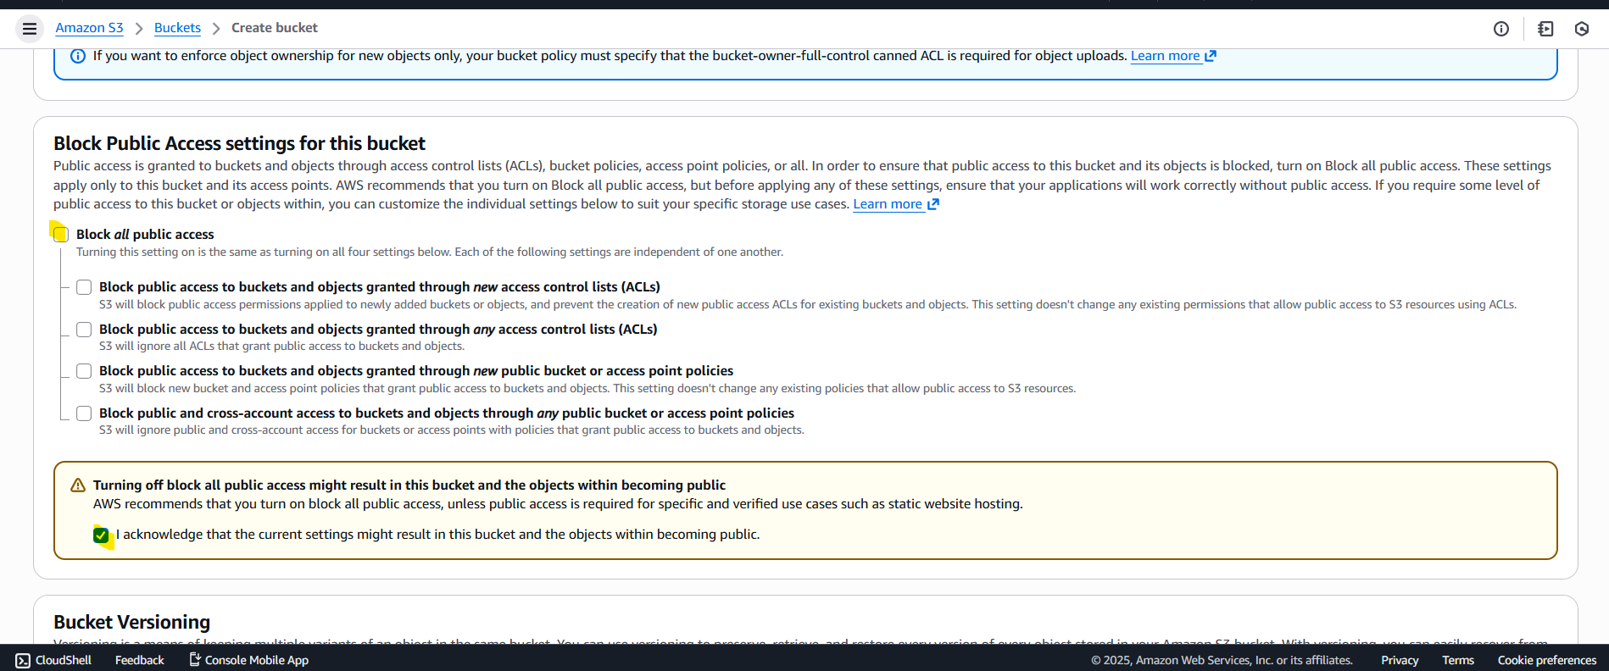
Step 8: Enable versioning if needed but mostly you can enable it after creation of bucket as well.
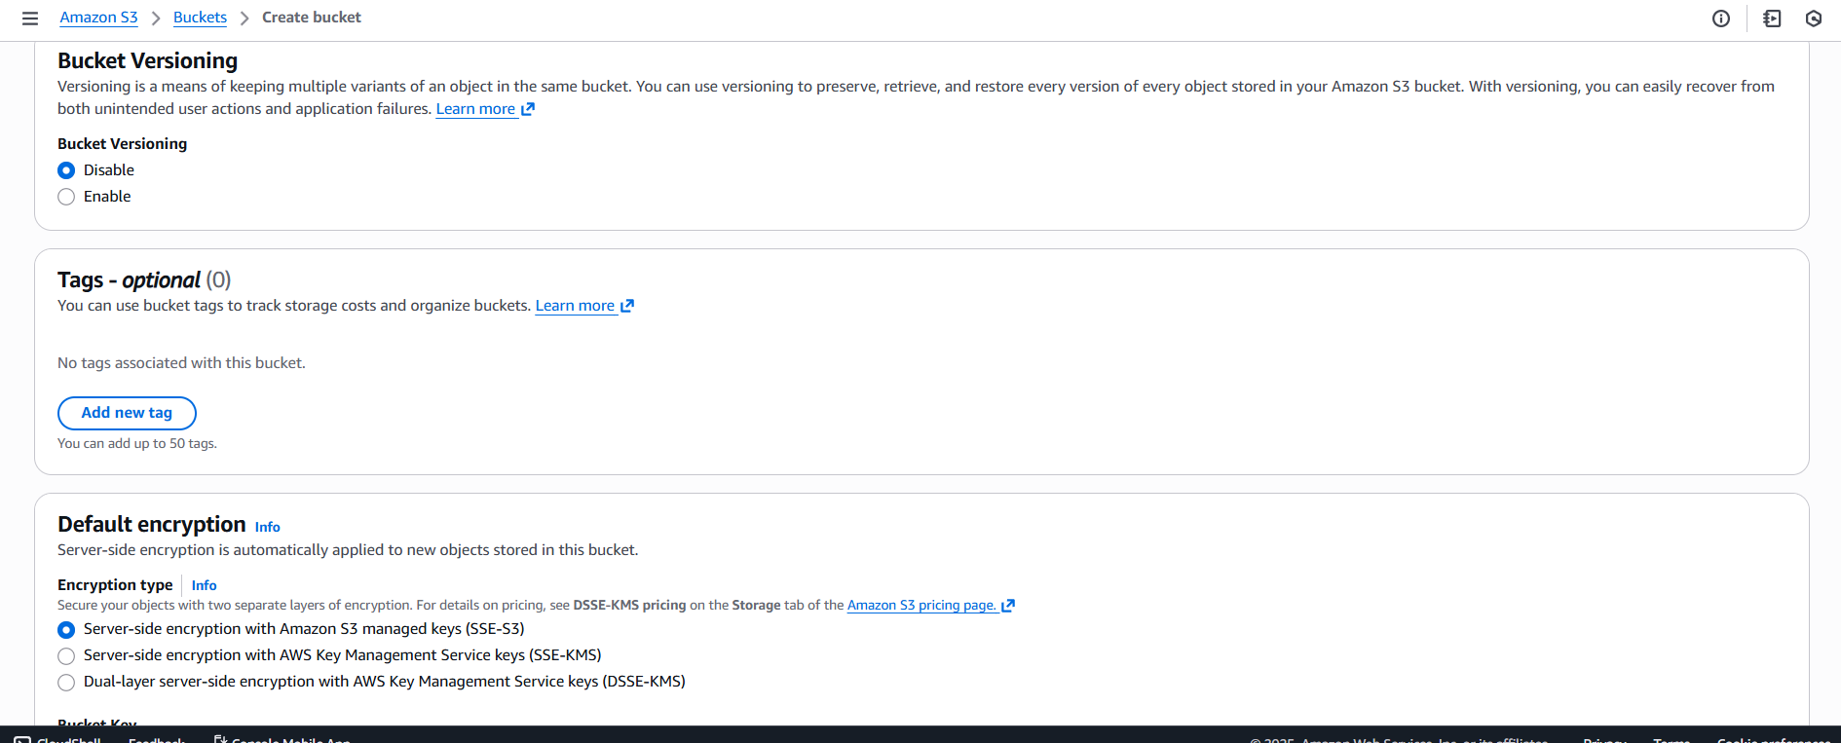

Step 9: click on create bucket
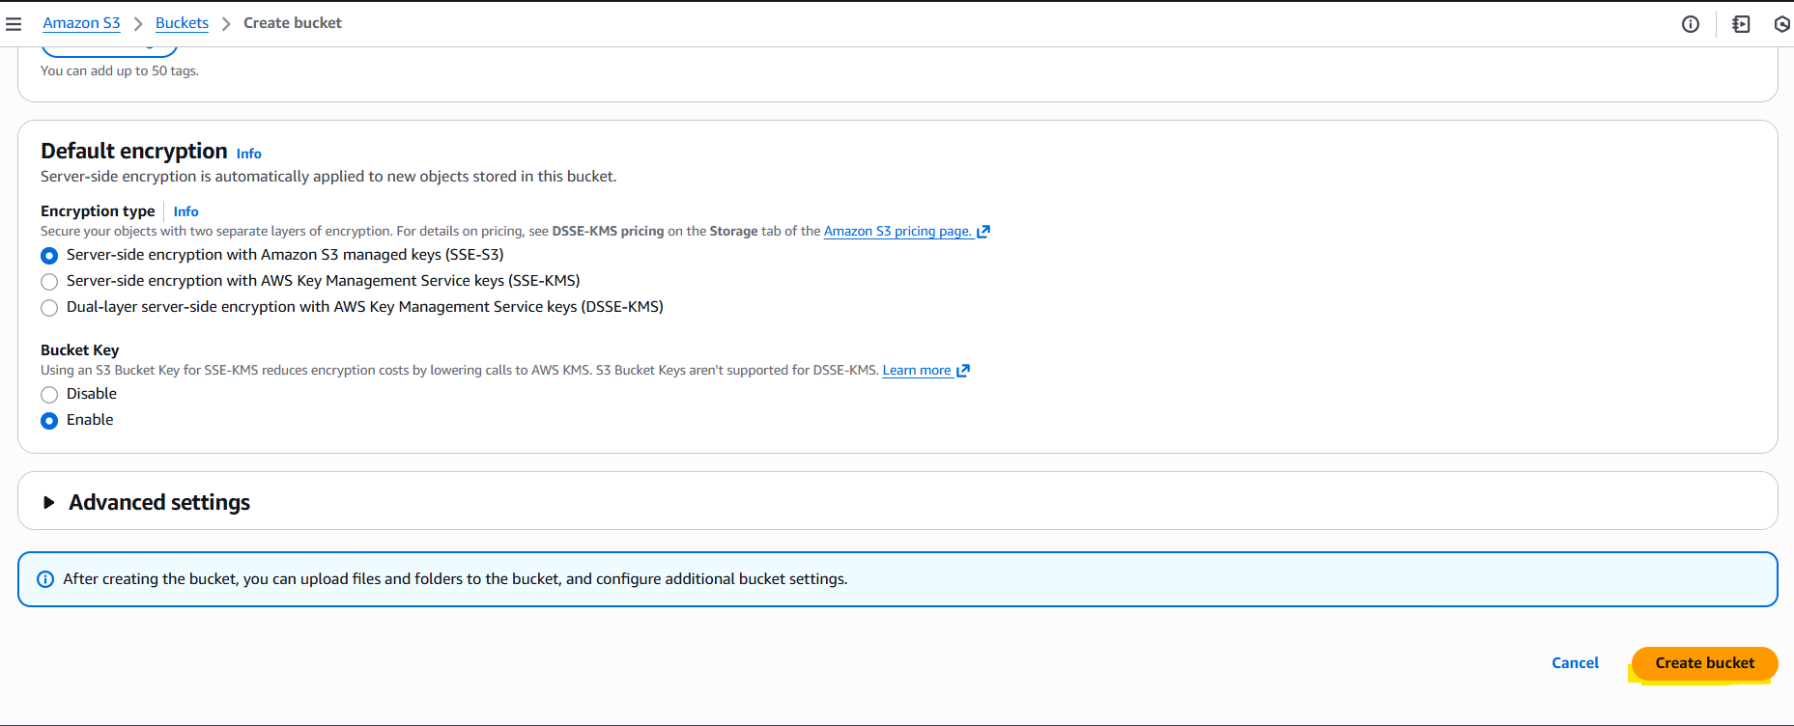
Step 10: bucket will get created
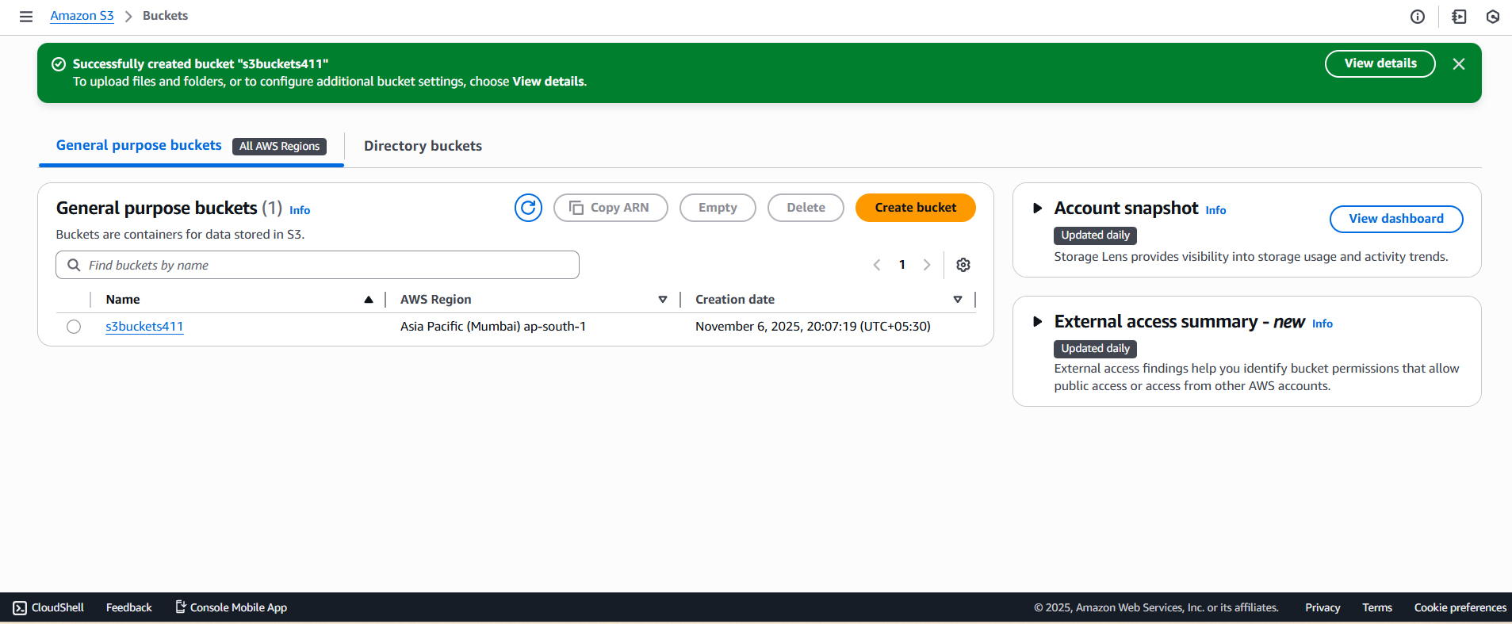

How to upload file in your bucket?
  - Open the bucket. Click on upload.
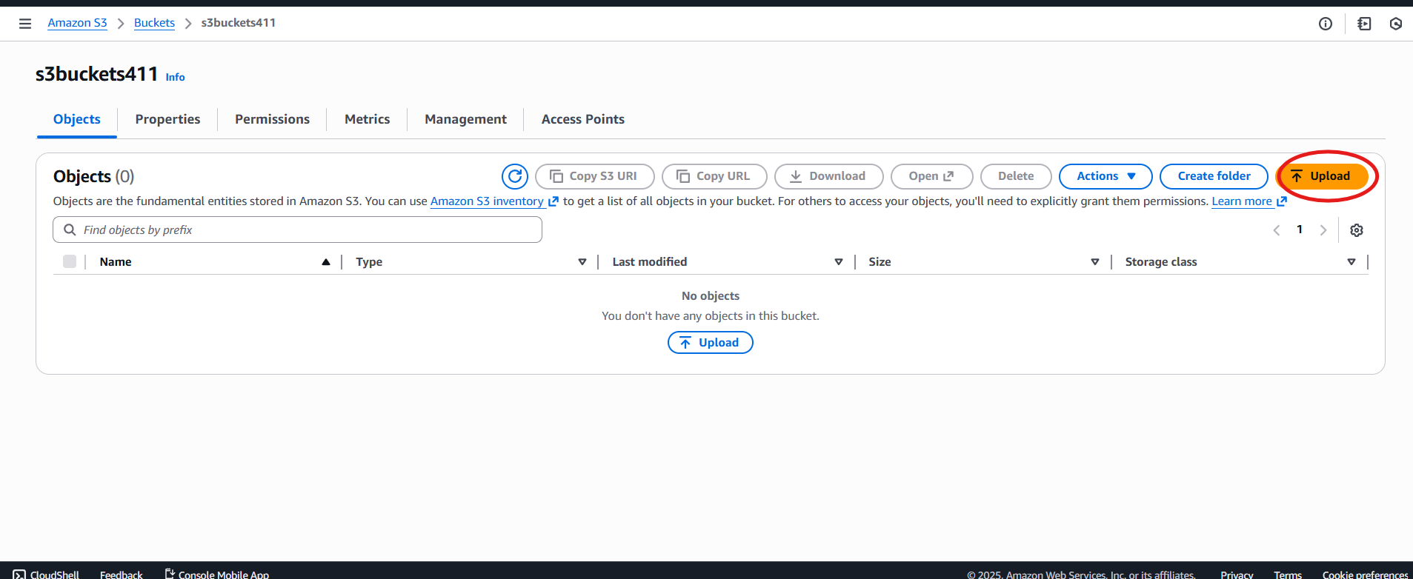
  - Click on add files
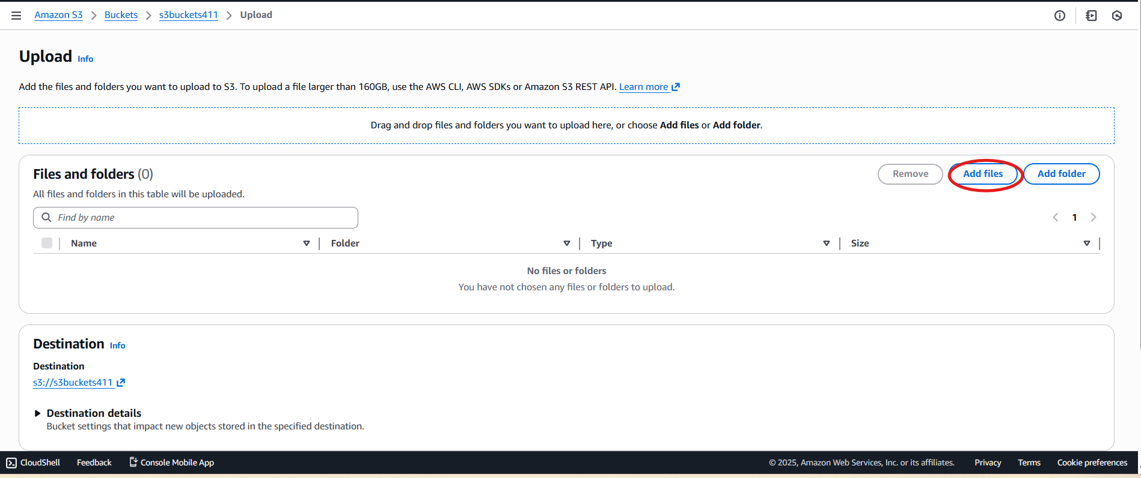
  - Click on permission
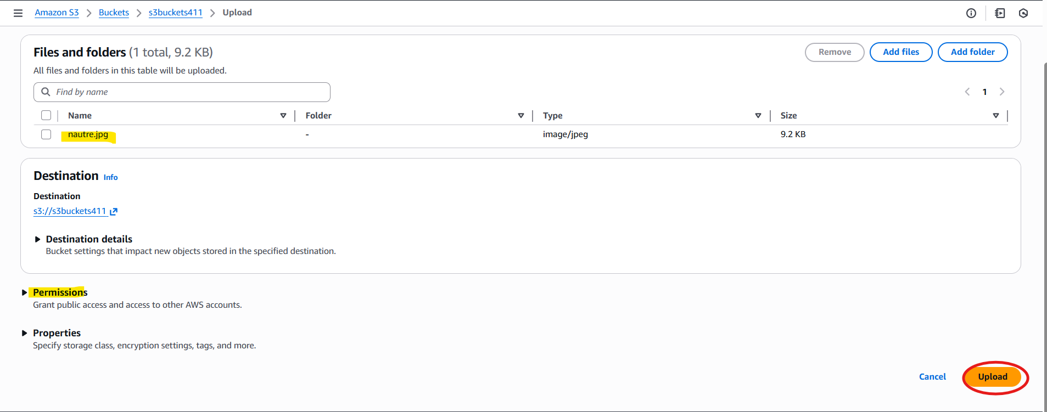
  - Provide public access then click on upload.
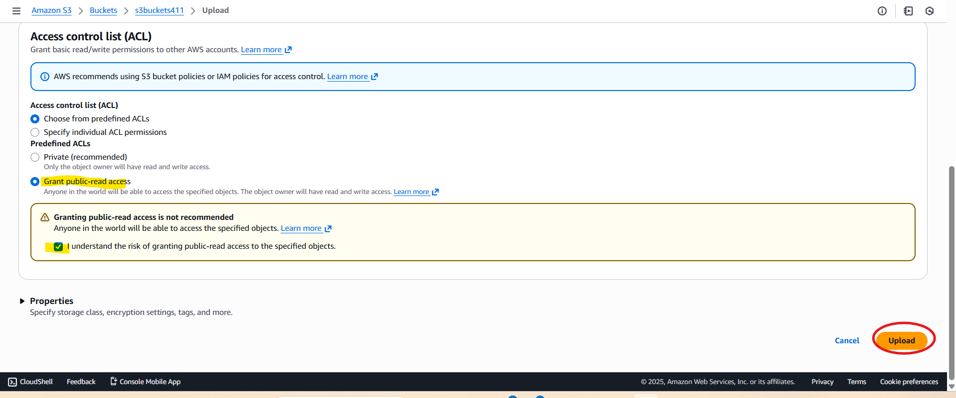

File will get uploaded to bucket
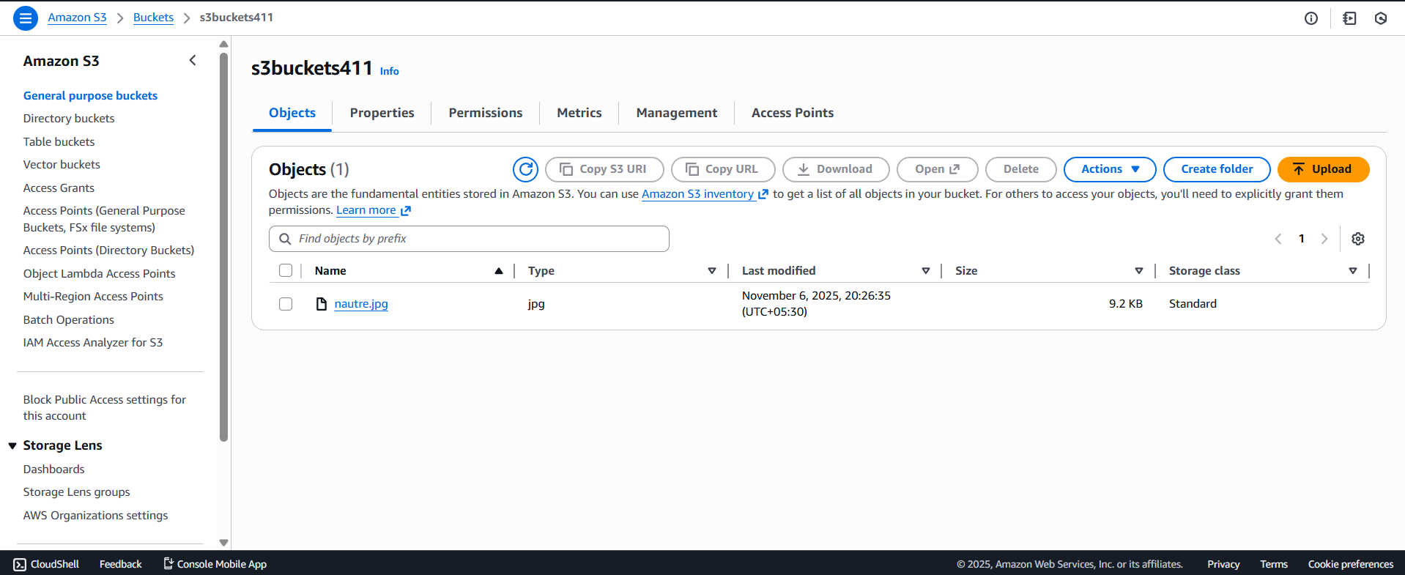

How to access file?
- Click on file
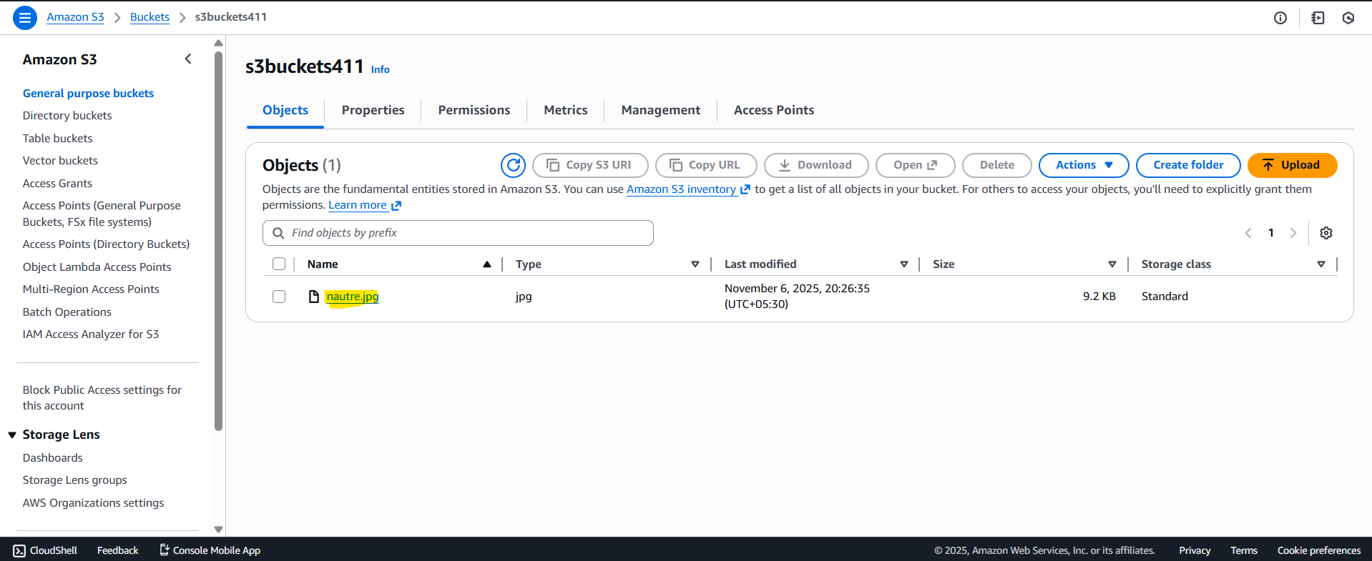
- You will get url
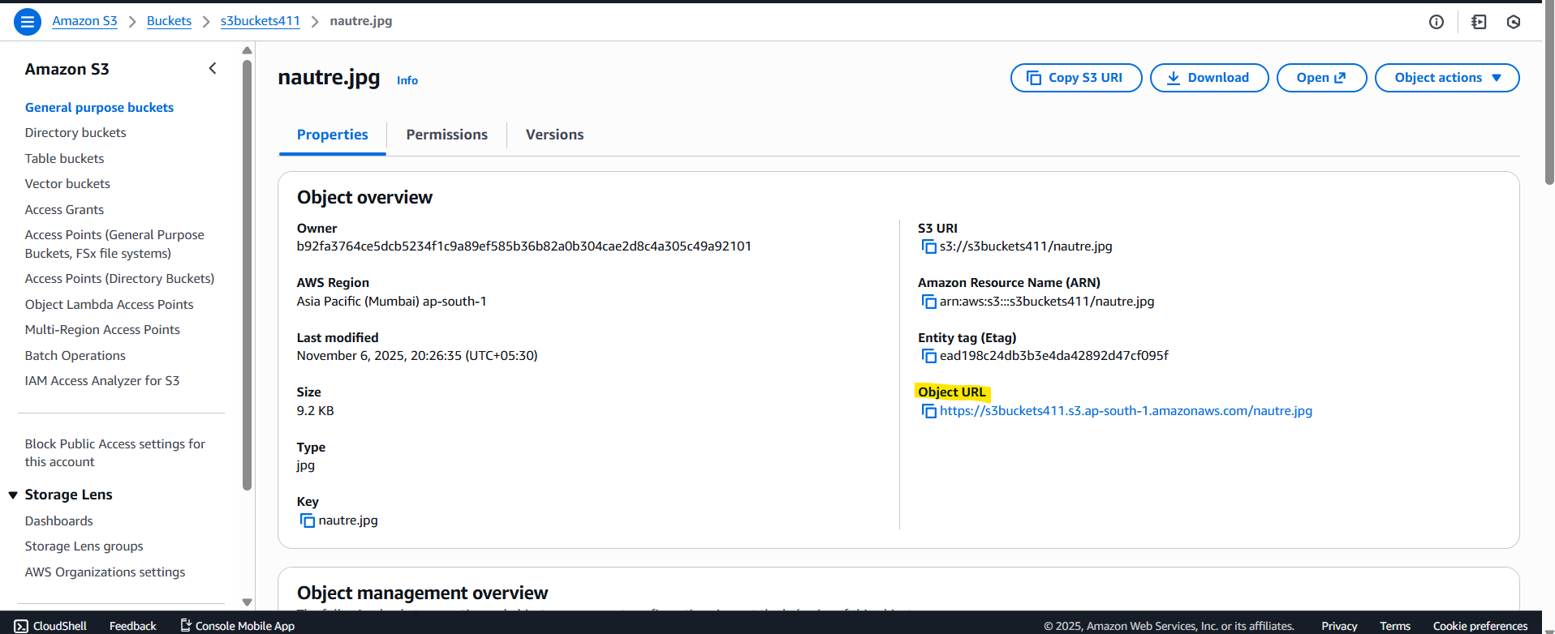
You will be able to access to file
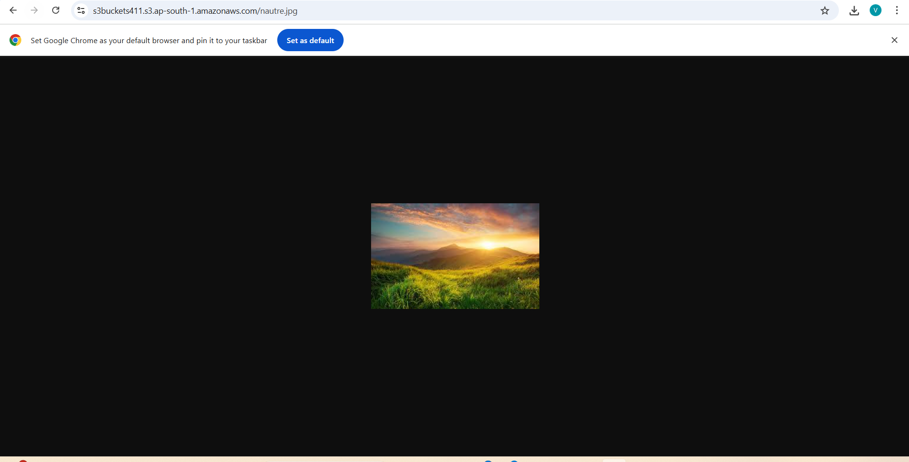

How to remove public access at file level?
- Click on file. Move to Permission tab
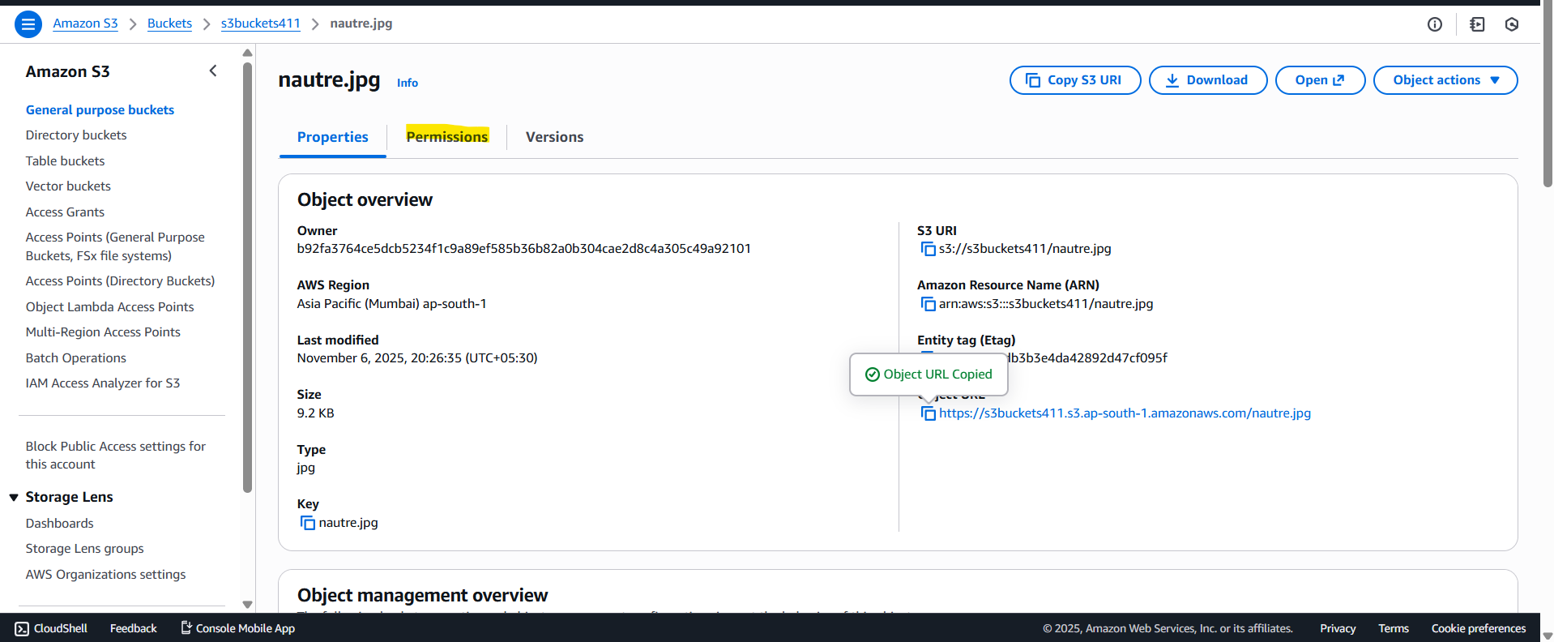
- Click on edit
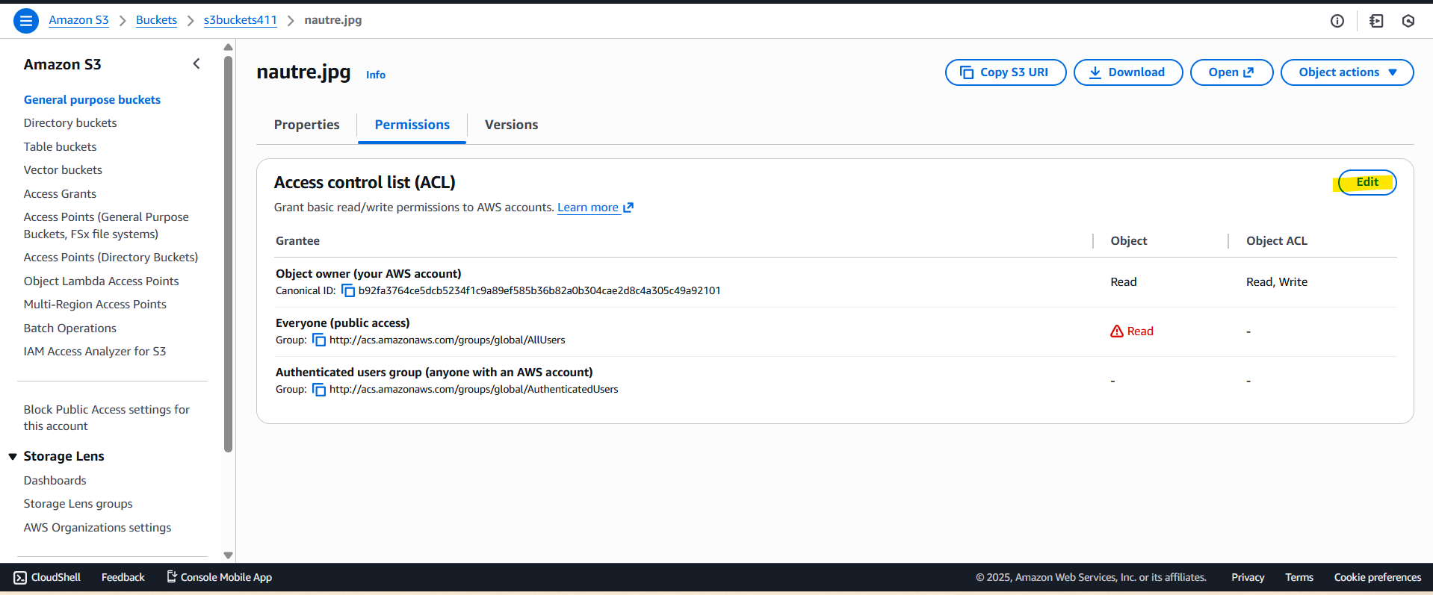
- Uncheck below box
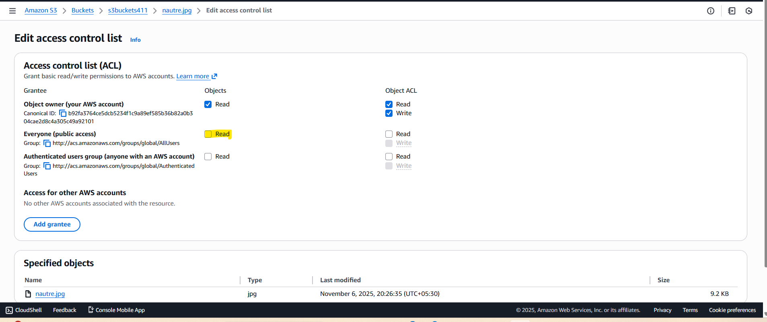
- Save changes
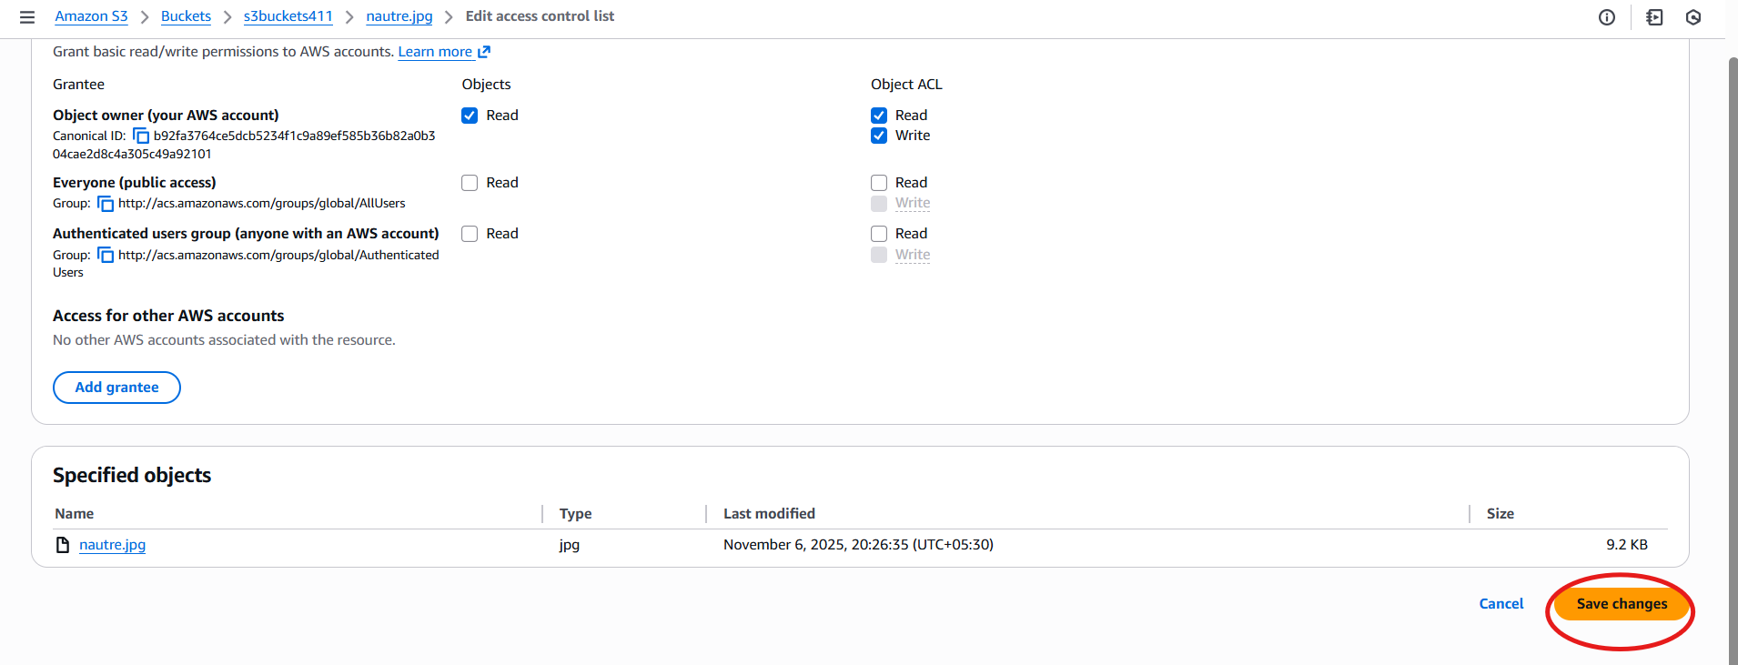
You will not able to access file now
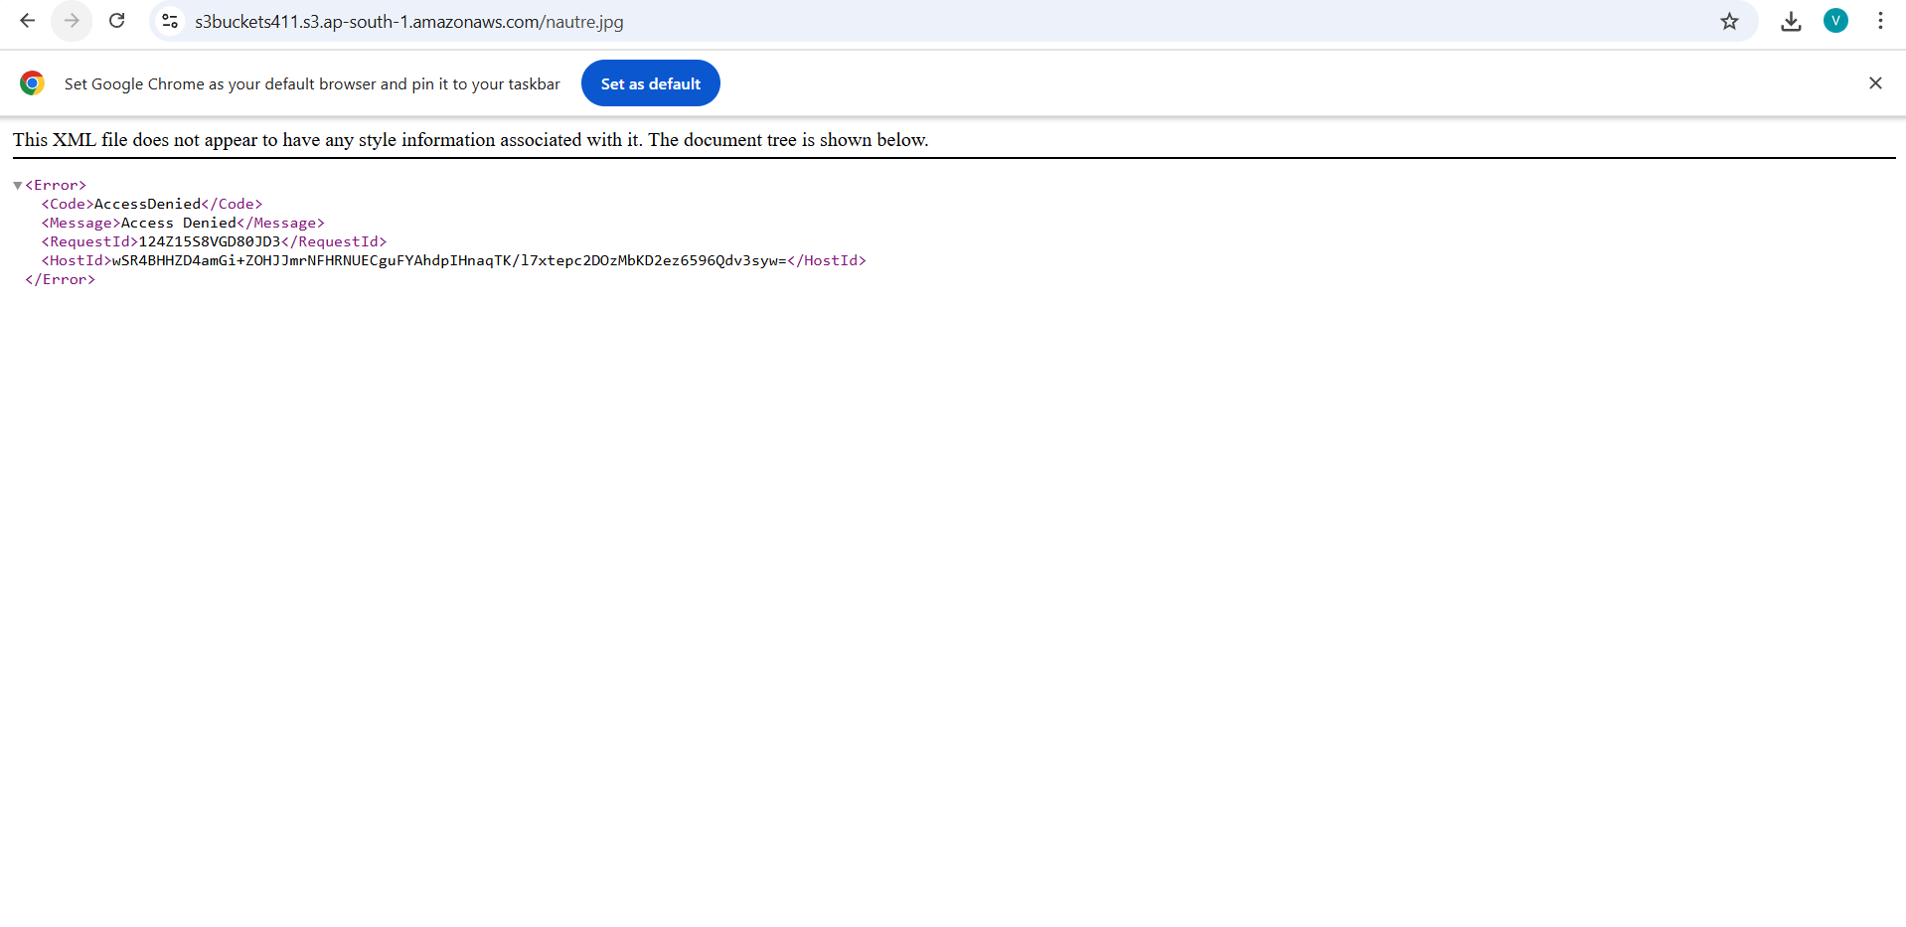
How to remove access at bucket level?
- Open the bucket Go to permissions.
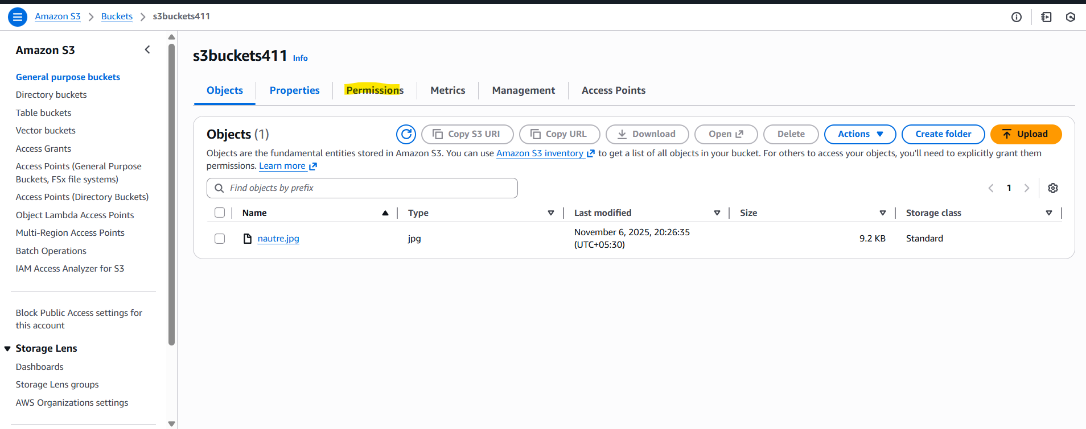
- Click on edit.
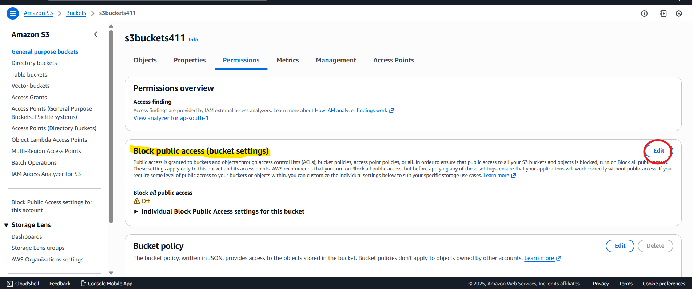
- Select the checkbox and save the changes.
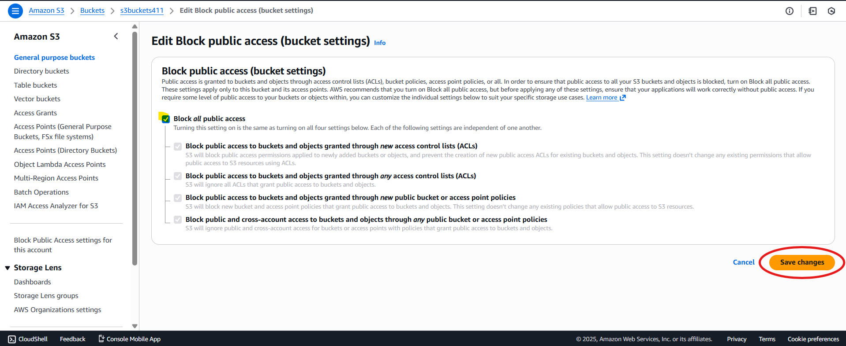
- Type confirm and click on confirm.
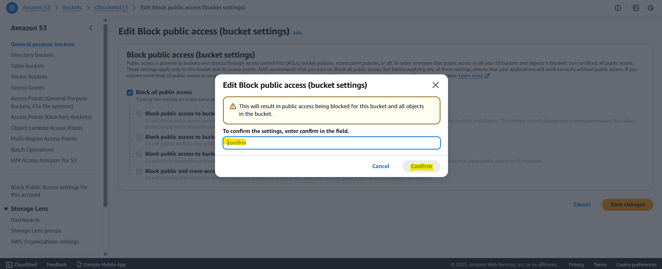
You will not be able to access file.
Note: To access file, you should have to provide public access at object level as well as a bucket level.
Versioning:
- Versioning in s3 buckets means keeping multiple variants of same Object (file) within same bucket.
- S3 versioning allows you to preserve, retrieve, and restore every version of every object stored in a bucket—even after deletion or overwrite.
- It’s a powerful safeguard for data integrity and recovery.
How it works?
- Versioning is a bucket-level feature that, when enabled, stores multiple versions of an object under the same key.
Same key means same object/ same name of file. E.g. world.txt under this file you will see different versions of file with different version id.
Example:
You upload world.txt three times:
- Each time you upload (PUT) or overwrite an object, Amazon S3 assigns a unique version ID to that object.
1.First upload → version ID v1
2.Second upload → version ID v2
3.Third upload → version ID v3

All three versions are stored in S3 with the same key worls.txt, but different version IDs.
- Even if you delete an object, S3 doesn’t remove it permanently—it adds a delete marker, which hides the object but retains previous versions.
- Delete Marker: A special version that makes the object appear deleted. You can remove it to “undelete” the object.
- Noncurrent Versions: Older versions that are no longer the latest. They remain accessible unless explicitly deleted

